🐍 Ruff Python Cheat sheet

Docs: https://docs.astral.sh/ruff/configuration/

1. Global Installation (Recommended)
Install Ruff globally using uv to keep it isolated from your system Python.
- Any System (via uv): uv tool install ruff@latest
- Mac (Homebrew): brew install ruff
- Windows/Linux (Standalone):
  - curl -LsSf https://astral.sh/ruff/install.sh | sh (Unix)
  - powershell -c "irm https://astral.sh/ruff/install.ps1 | iex" (Windows)

2. Most Used Commands
Run these in your project's root folder:
- ruff check . – Scan for errors in the current folder and subdirectories.
- ruff check --fix – Automatically fix safe errors, like removing unused imports.
- ruff format . – Instantly clean up code styling (indentation, quotes, etc.).
- ruff rule F401 – Explain a specific error code with examples.
- uv tool upgrade ruff – Update your global Ruff version to the latest.

3. VS Code Automation (settings.json)
Add this to your VS Code settings to fix code automatically every time you save:
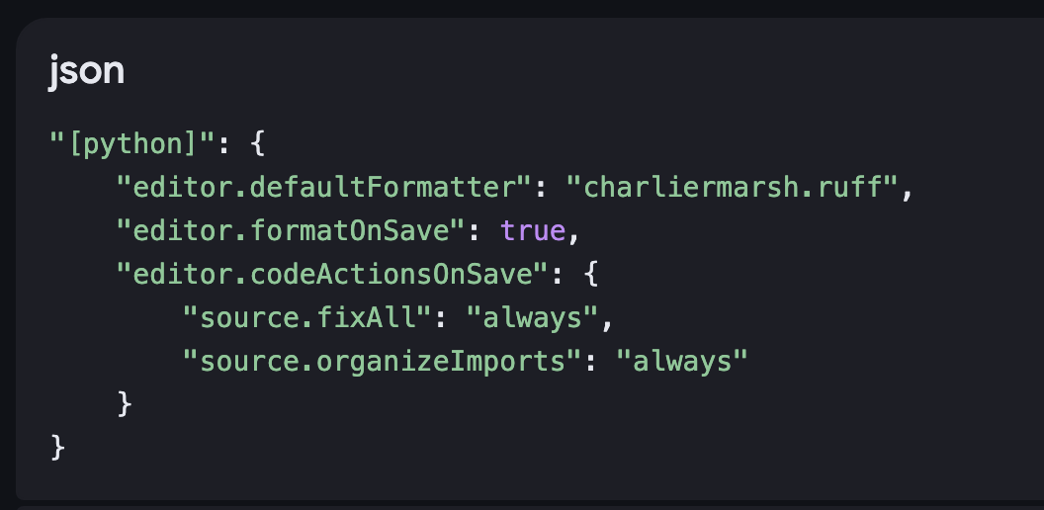
"[python]": {
"editor.defaultFormatter": "charliermarsh.ruff",
"editor.formatOnSave": true,
"editor.codeActionsOnSave": {
"source.fixAll": "always",
"source.organizeImports": "always"
}
}

4. Common Rule Groups
Select these in your config to enable specific checks:
- E / W (pycodestyle): Standard Python style errors and warnings.
- F (Pyflakes): Critical logic errors like undefined names or unused imports.
- I (isort): Alphabetical sorting and grouping of imports.
- UP (pyupgrade): Automatically upgrades old syntax (e.g., old string formatting).
- B (flake8-bugbear): Detects non-obvious design bugs and likely mistakes.

5. Project Configuration (pyproject.toml)
Create this file in your project root to lock in these rules for everyone:
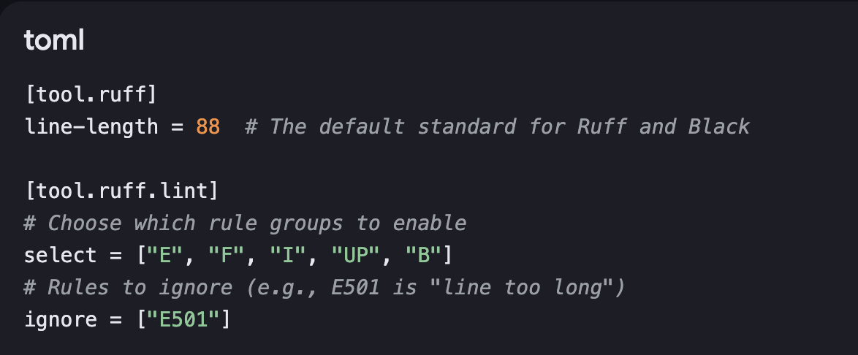
[tool.ruff]
line-length = 88 # The default standard for Ruff and Black

[tool.ruff.lint]
# Choose which rule groups to enable
select = ["E", "F", "I", "UP", "B"]
# Rules to ignore (e.g., E501 is "line too long")
ignore = ["E501"]

[tool.ruff.lint]
select = ["E", "F", "I", "UP", "B"]
# This tells Ruff: "Sort them (I), but NEVER delete them (F401)"
unfixable = ["F401"]
never delete unused imports

MISCELANNEOUS
